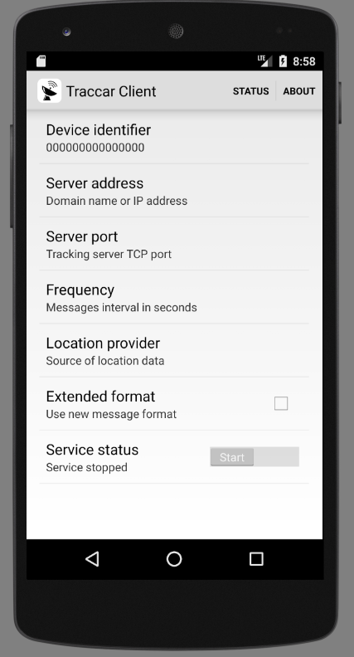

Traccar Client – ‘Main’ screen before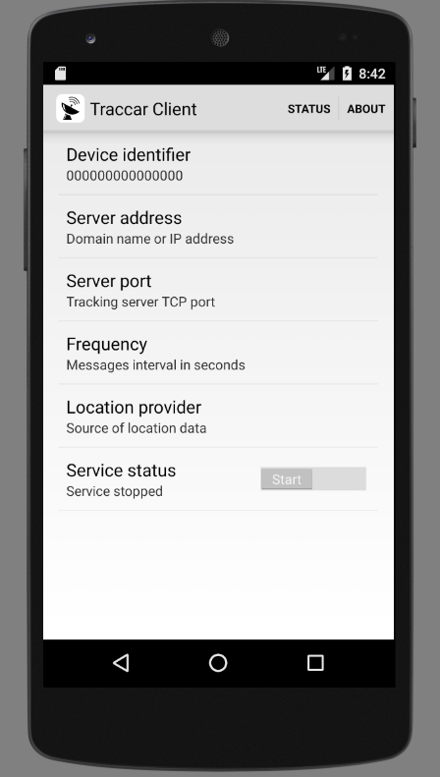

Traccar Client – ‘Main’ screen after (removal of ‘Extended format’ option)

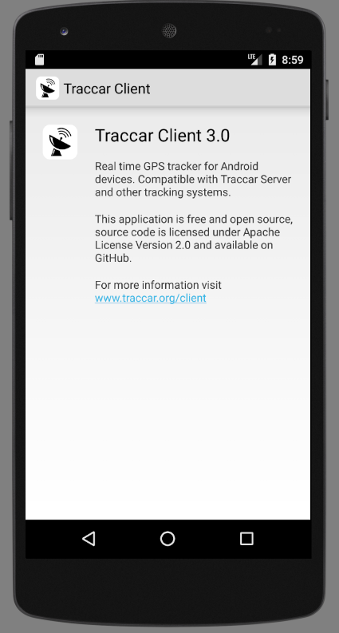

Traccar Client – ‘About’ screen before

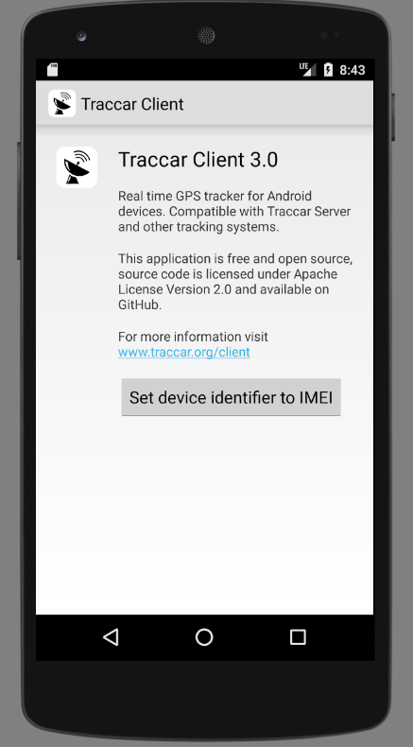

Traccar Client – ‘About’ screen after (added the option to set the device identifier to the IMEI number of the device)

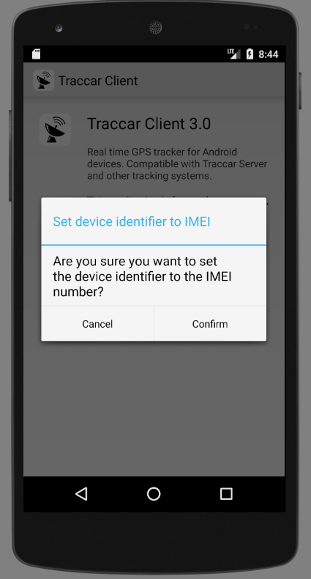

Traccar Client – ‘About’ screen confirmation

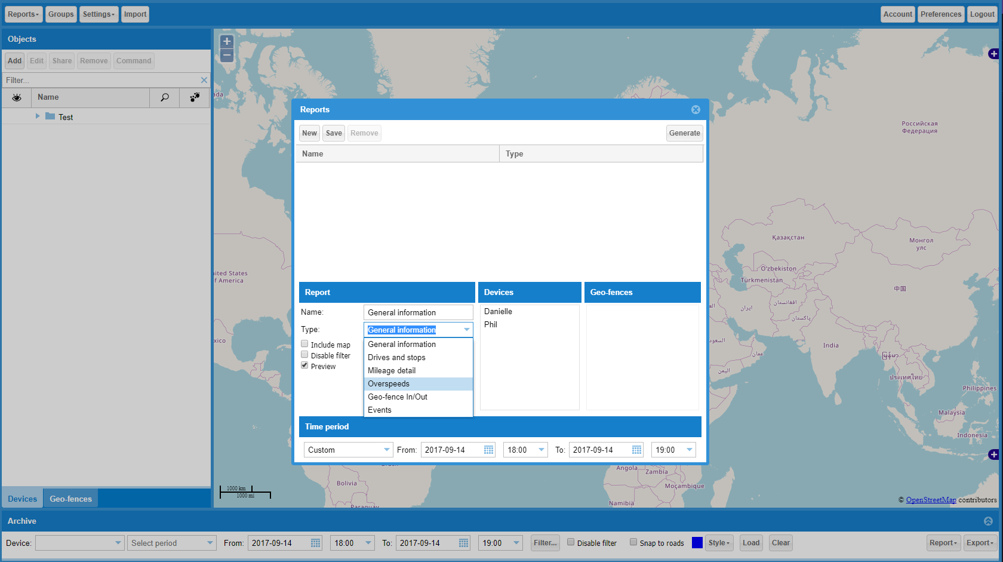

Traccar Web UI – ‘Reports’ before

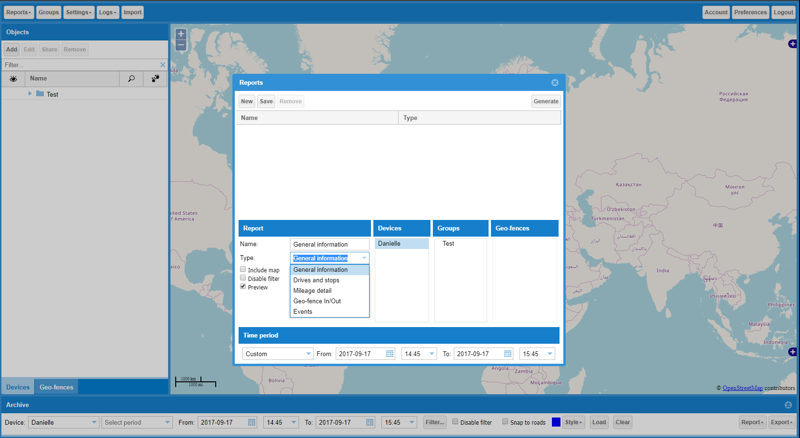

Traccar Web UI – ‘Reports’ after (removal of ‘Overspeeds’)

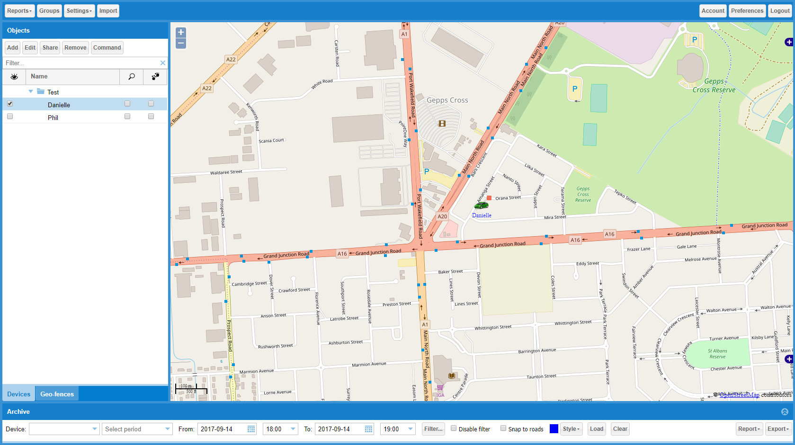

Traccar Web UI – icons before

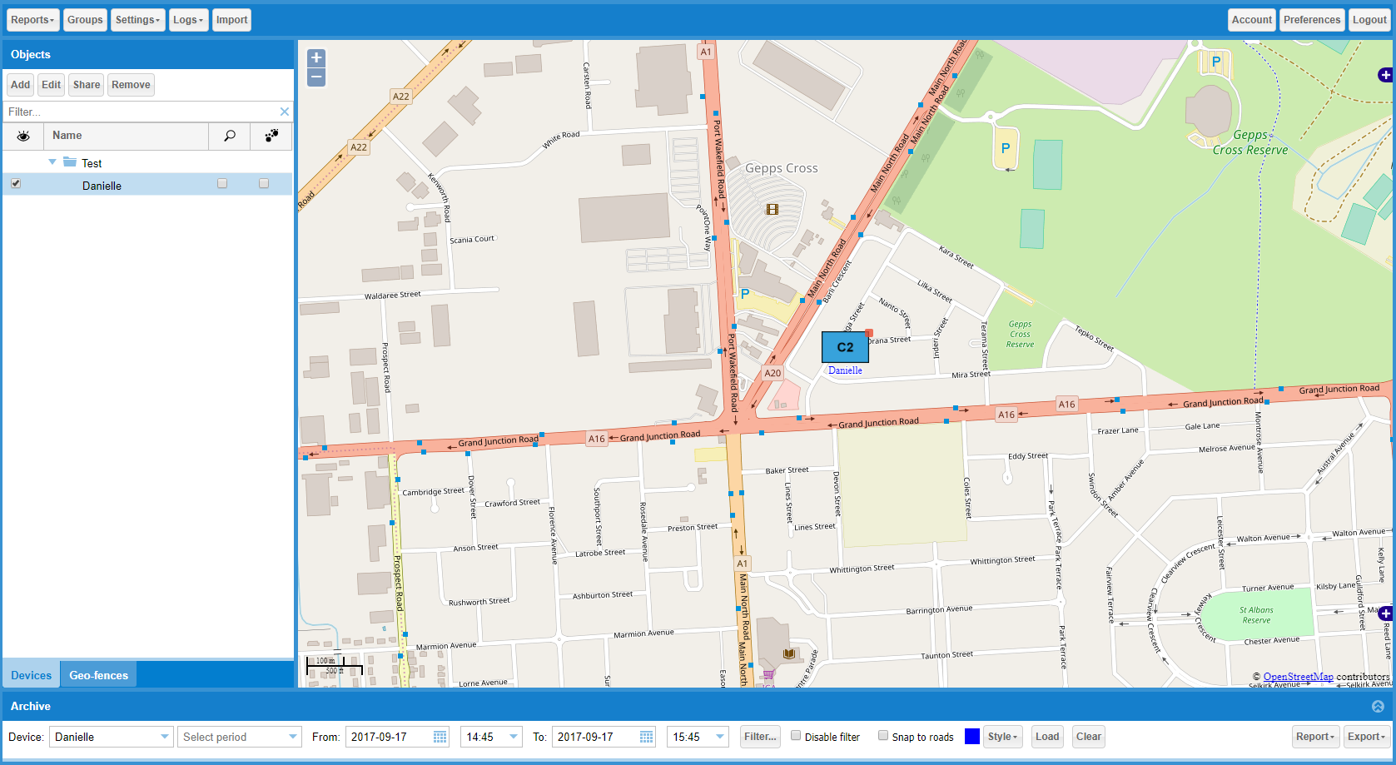

Traccar Web UI – icons after (added military symbology)

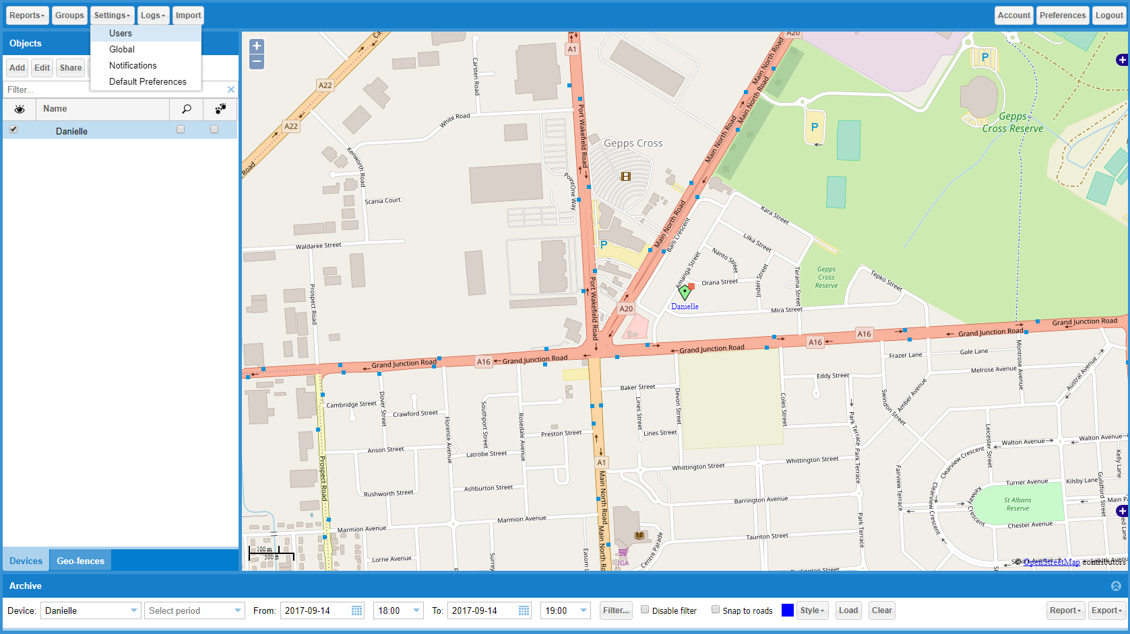

Traccar Web UI – ‘Settings’ before

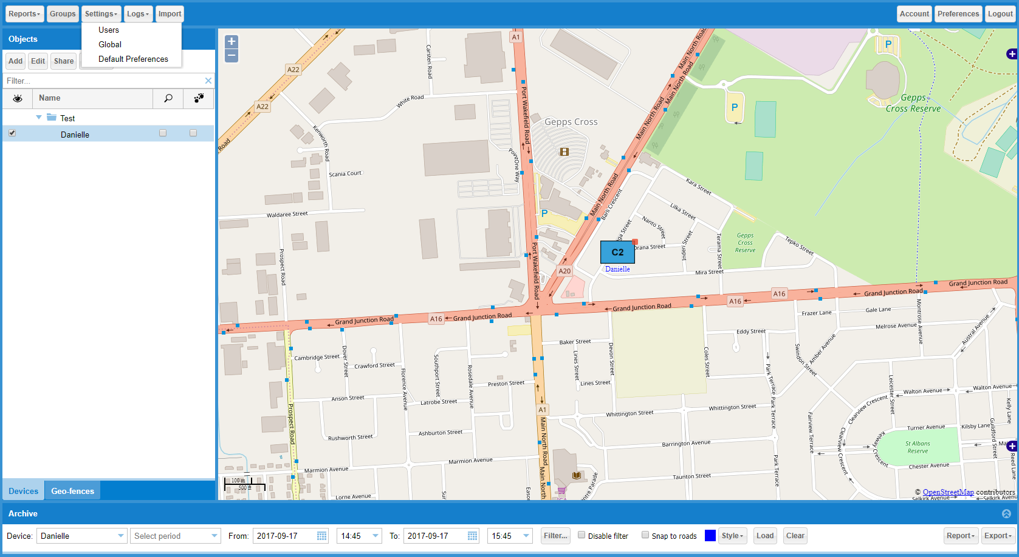

Traccar Web UI – ‘Settings’ after (removal of ‘Notifications’)

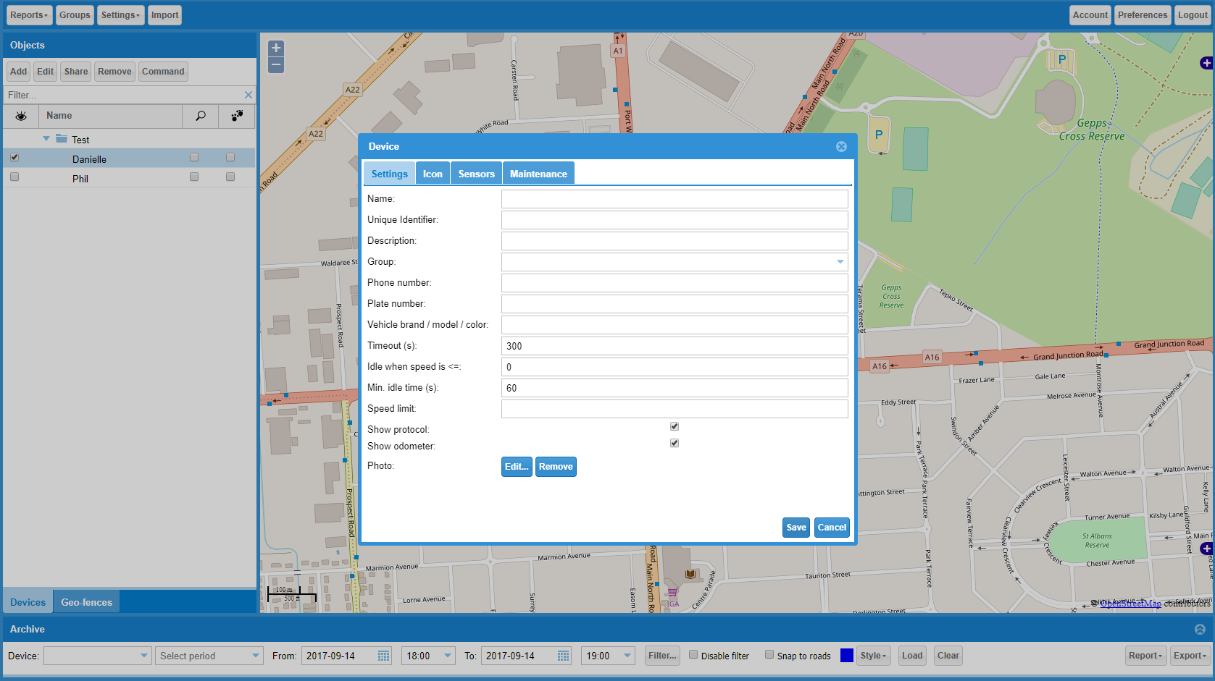

Traccar Web UI – ‘Device’ before

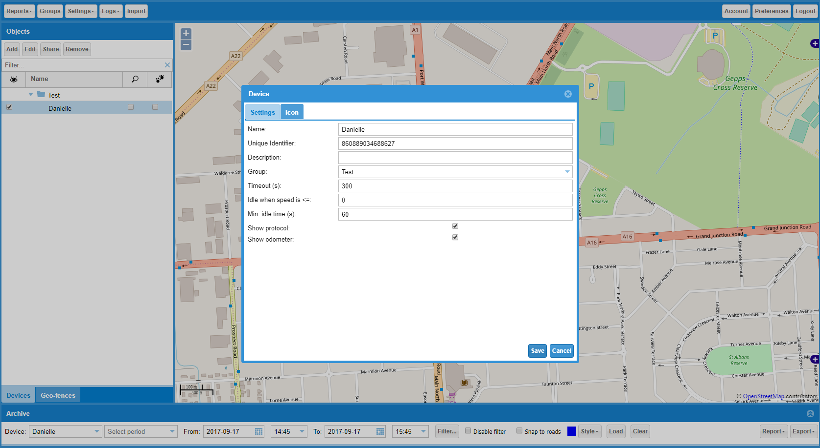

Traccar Web UI – ‘Device’ after (removal of ‘Sensors’, ‘Maintenance’, and other attributes)

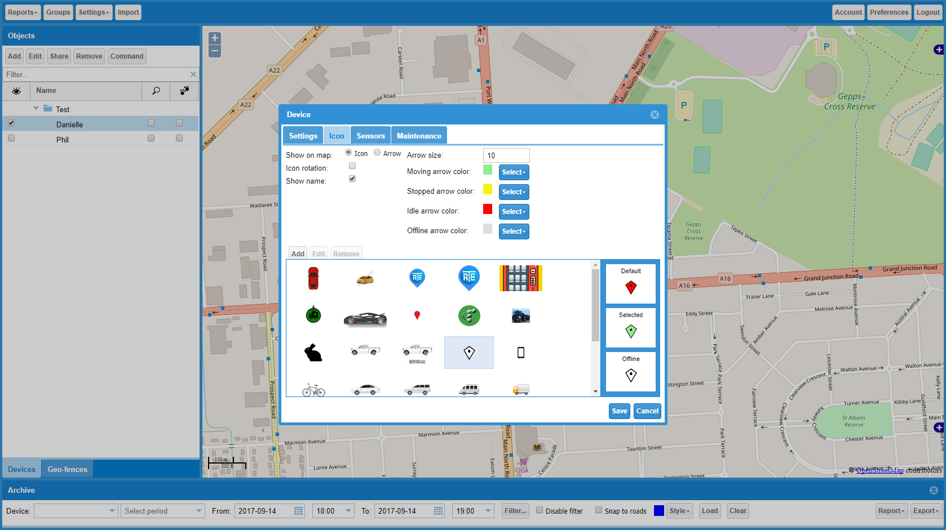

Traccar Web UI – ‘Device Icon’ before

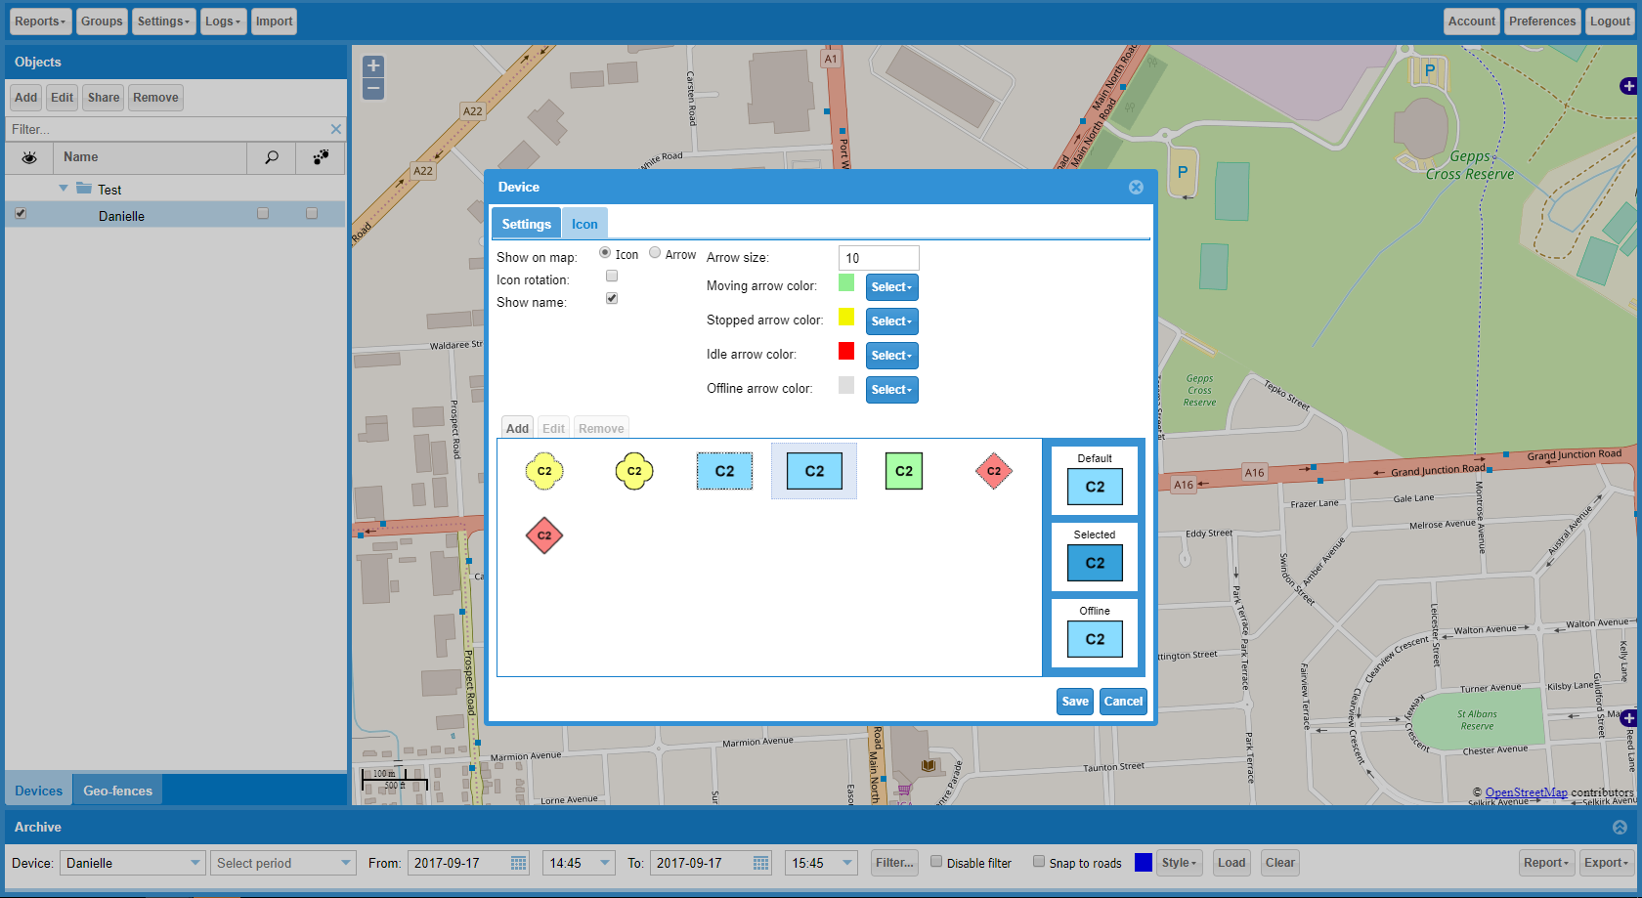

Traccar Web UI – ‘Device Icon’ after (added military symbology, removed existing icons)

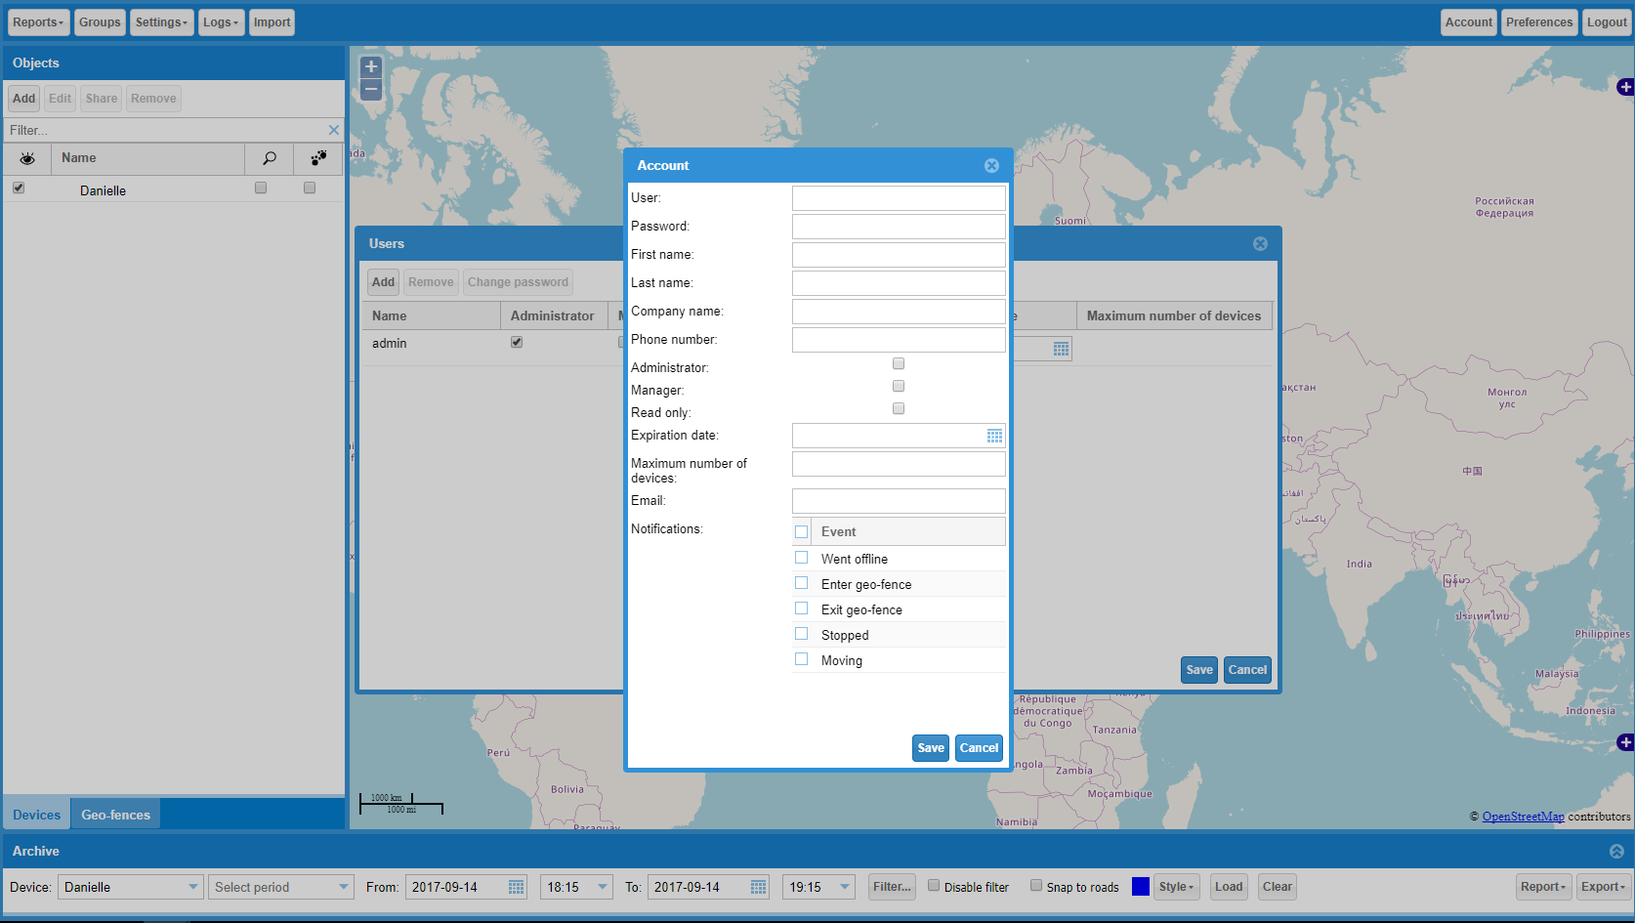

Traccar Web UI – ‘Account’ before

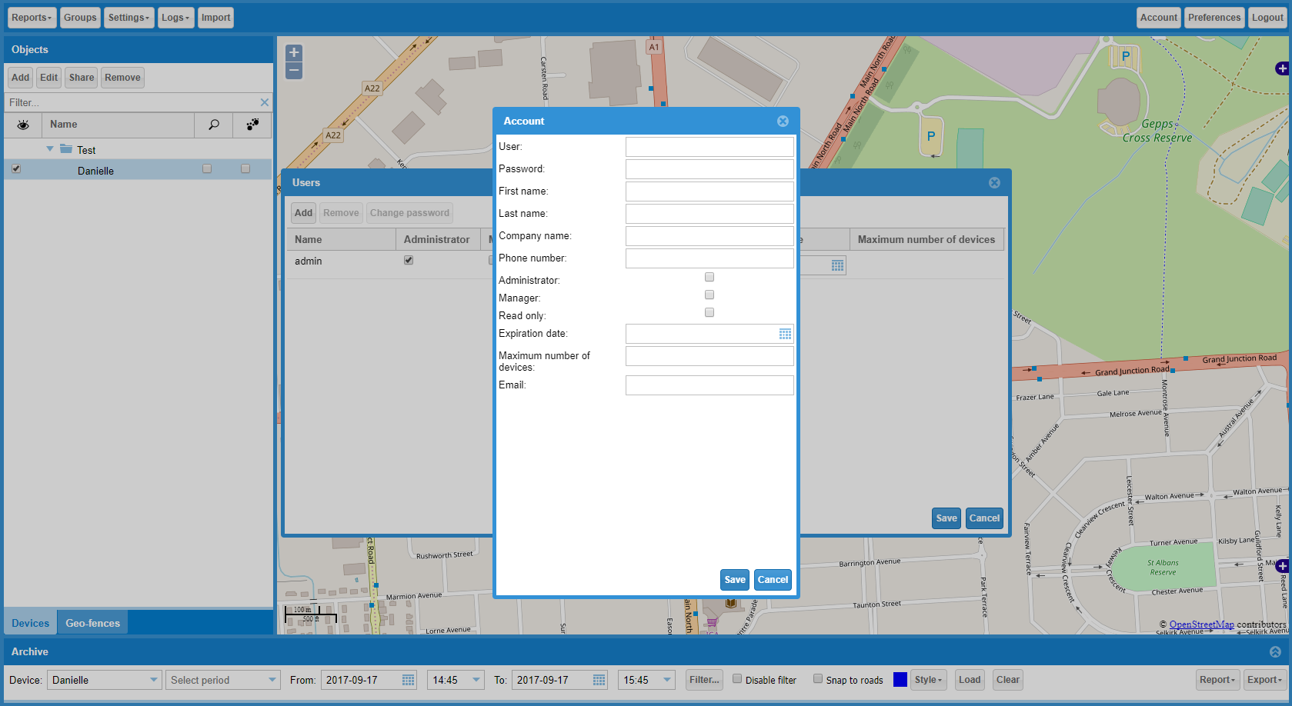

Traccar Web UI – ‘Account’ after (removed ‘Notifications’)

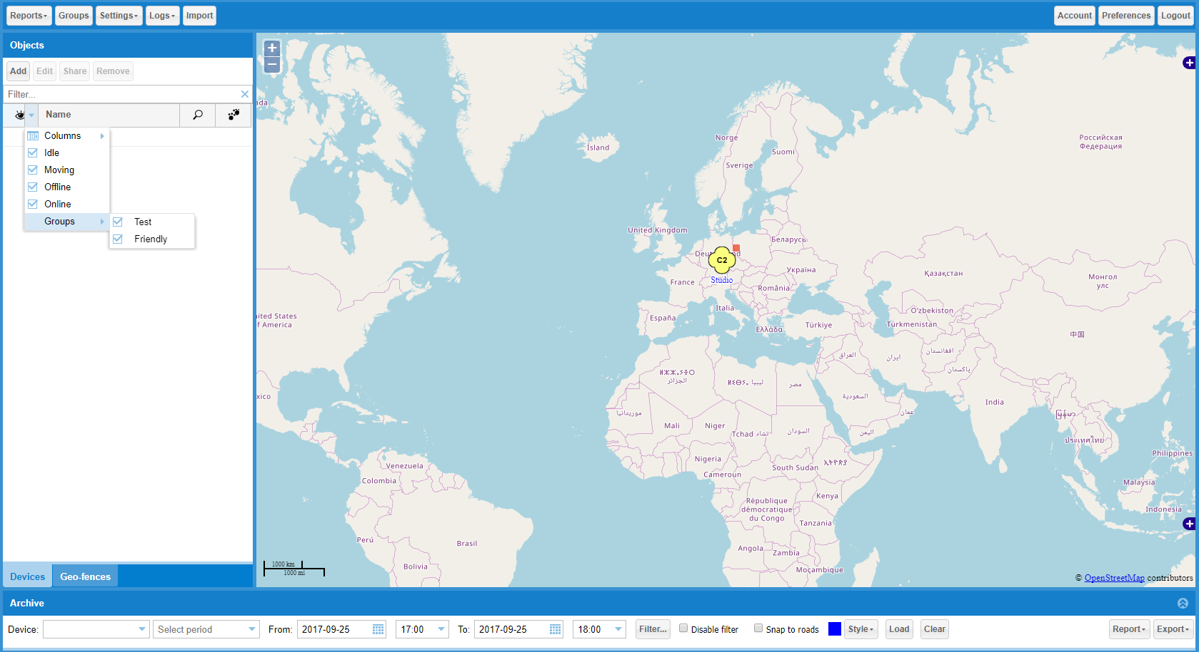

Traccar Web UI – ‘Visibility Filter’ before

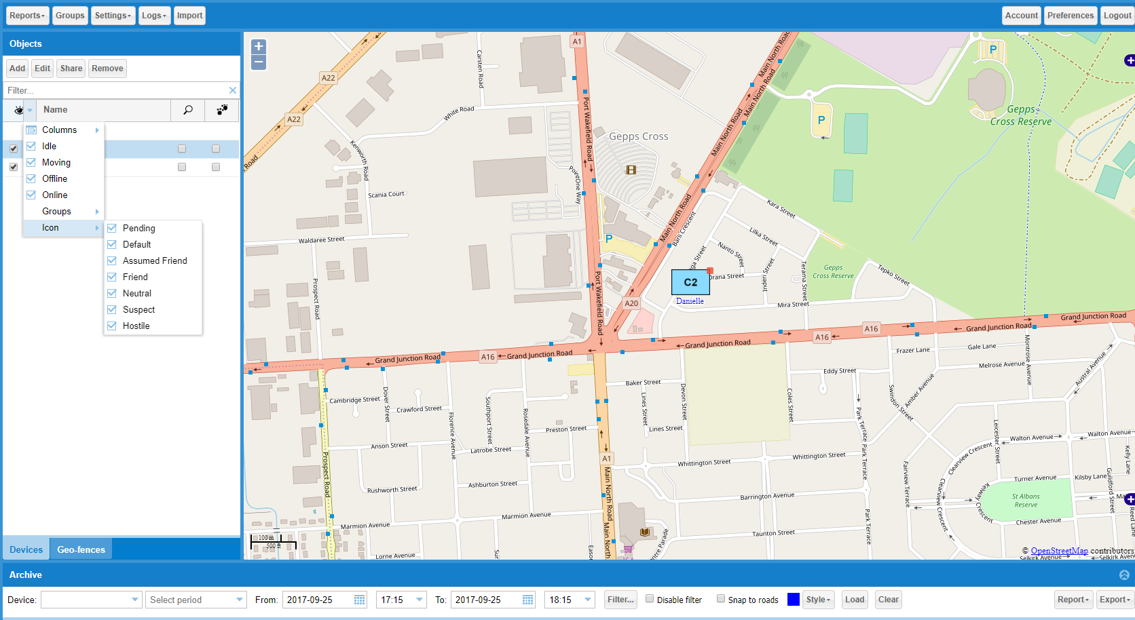

Traccar Web UI – ‘Visibility Filter’ after